Donation Form | 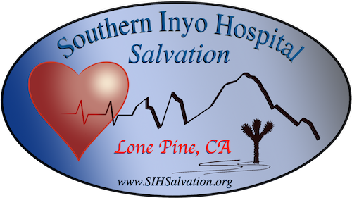

SIH Salvation thanks you for donating. All donations will be used to further our Mission, which is to financially assist Southern Inyo Hospital with Capital Equipment Purchases, Physical Plant Upgrades, and in other ways provide for the health and well-being of patients, residents, and staff. You can fill this form out and mail this along with your check to the address below. If you choose to send cash, please bring this form and your cash to Linda directly.

Donor Information
BUSINESS NAME | NAME (LAST, FIRST, M.I.)
STREET ADDRESS | EMAIL
CITY, STATE, ZIP | PHONE
WEBSITE | ALTERNATE PHONE

Donation Description
CHECK ALL THAT APPLY: CHECK CASH SPECIFIC PROJECT TAX-DEDUCTIBLE
AMOUNT / DESCRIPTION | DATE
NOTES

Contact Information
Southern Inyo Hospital Salvation  PO Box 382  Lone Pine, California 93545  www.sihsalvation.org | Daniel Smith  President  Phone: (760) 614-0194  Email: daniel@sihsalvation.org

